**AWS Assessment Project 3**

**Project: Provision EC2 instance with Lambda**

|  |  |
| --- | --- |
| **Task 1** | Login to AWS console |
| **Task 2** | Create am IAM Policy and an IAM Role |
| **Task 3** | Create a Lamb da Function |
| **Task 4** | Configure Test Event |
| **Task 5** | Trigger the Lambda Function manually using the test event |

TASK 1: Log into the AWS Management Console

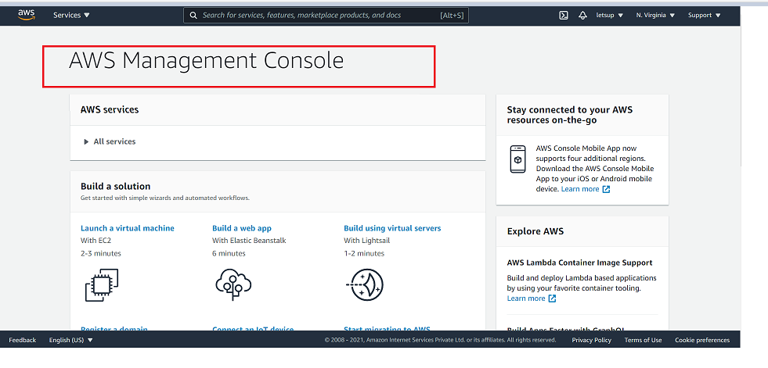

TASK 2: Create an IAM Policy

**SS1: Create IAM policy with EC2 configuration**

* **IAM Policy**
* **First create an IAM role using the JSON script.**

{

"Version": "2012-10-17",

"Statement": [

{

"Effect": "Allow",

"Action": [

"ec2:Describe*",

"ec2:CreateKeyPair",

"ec2:CreateSecurityGroup",

"ec2:AuthorizeSecurityGroupIngress",

"ec2:AuthorizeSecurityGroupEgress",

"ec2:CreateTags",

"ec2:DescribeTags",

"ec2:RunInstances"

],

"Resource": "*",

"Condition": {

"StringEquals": {

"ec2:Region": "us-east-2"

}}}

]}

* **EC2 Configuration**

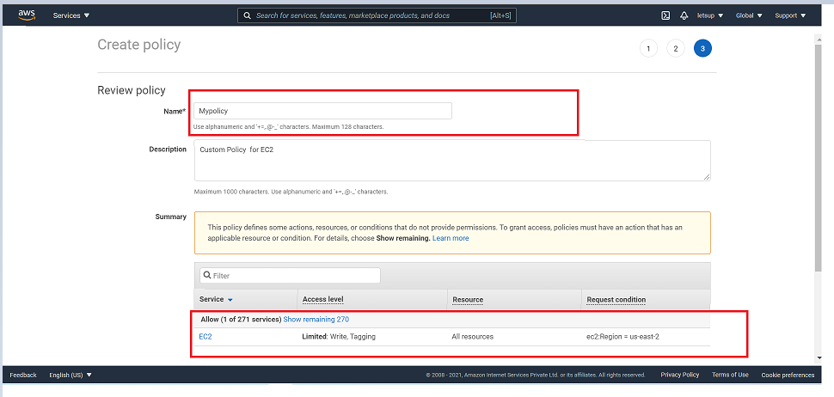

|  |  |  |  |
| --- | --- | --- | --- |
| **Sr. No.** | **Name** | **Service** | **Access Level** |
| 1. | Mypolicy | EC2 | Write, Tagging |

**SS2: Create Role**

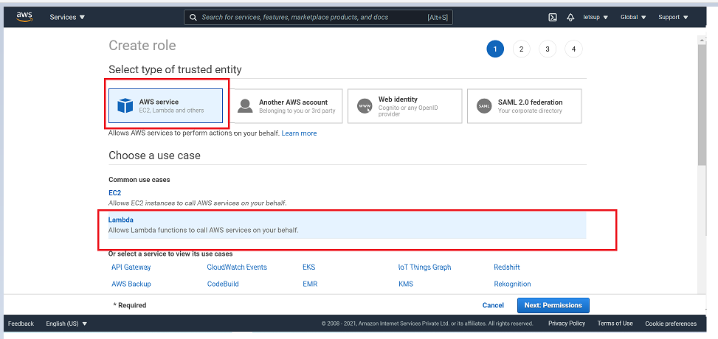

**Attach Permission Policies**

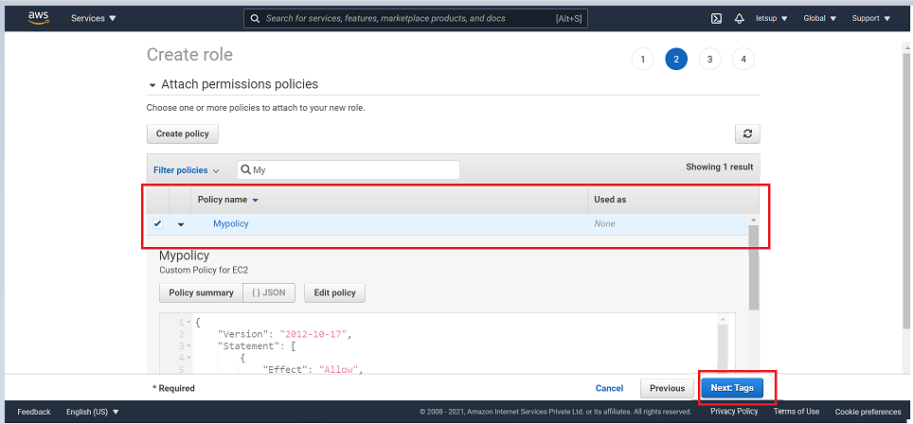

**Review**

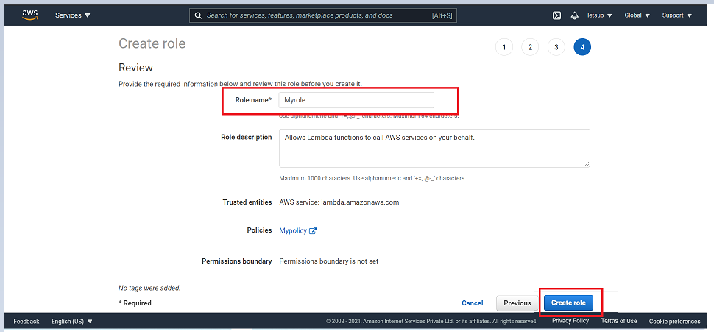

**TASK 3: Create Lambda Function**

* Click on create function.
* Select the runtime as Python 3.8.
* Select the created IAM role and assign.
* Click on create function.

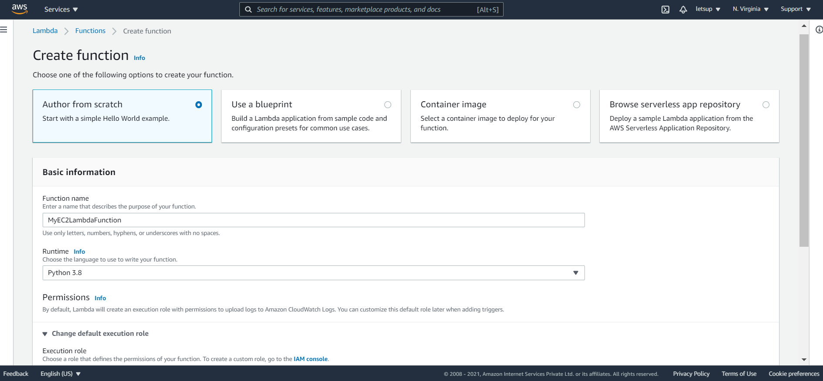

**SS3: Lambda Function – Code Configuration**

* Move down to my lambda functions and paste the code and deploy the lambda function.

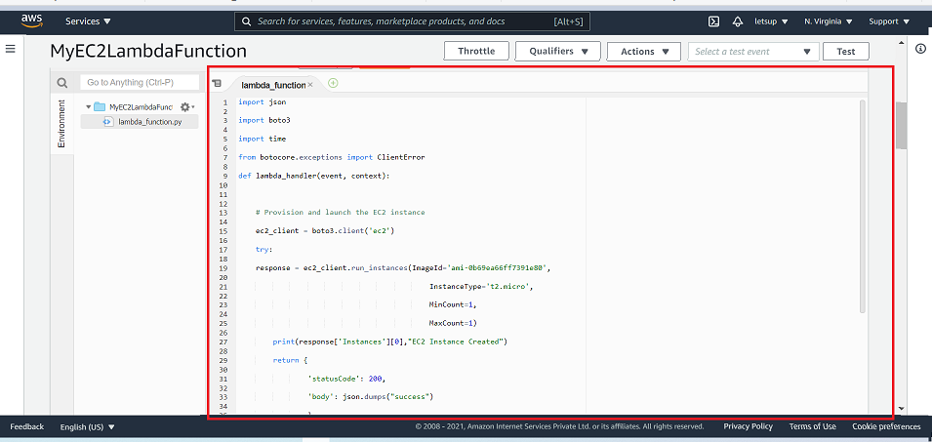

**SS4: Timeout Setting**

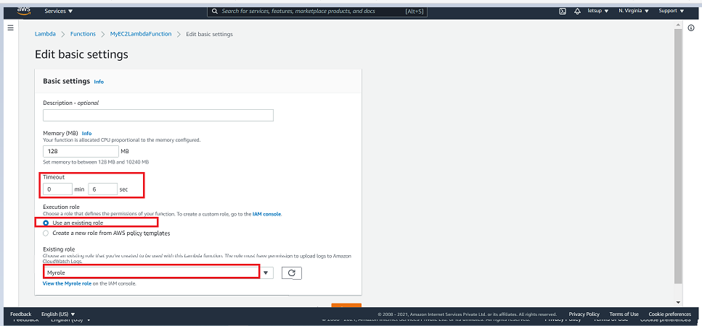

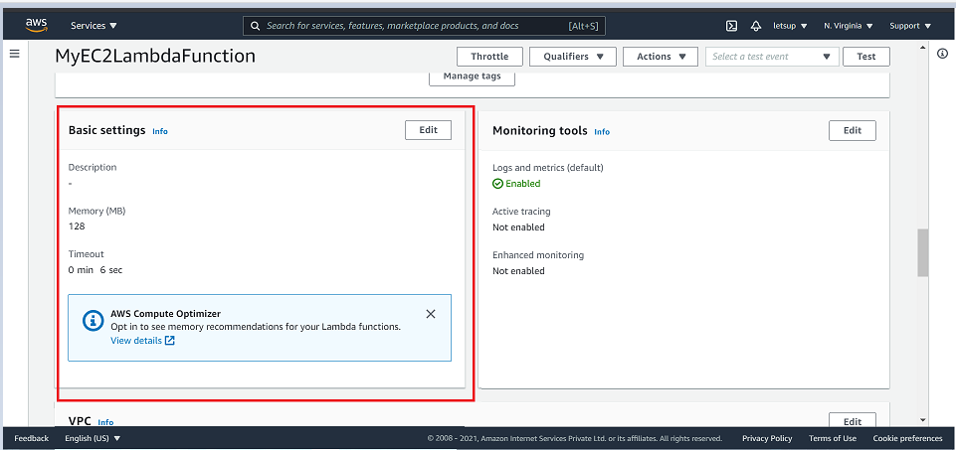

**TASK 4: Configure Test Event**

**SS5: Configuring the test page**

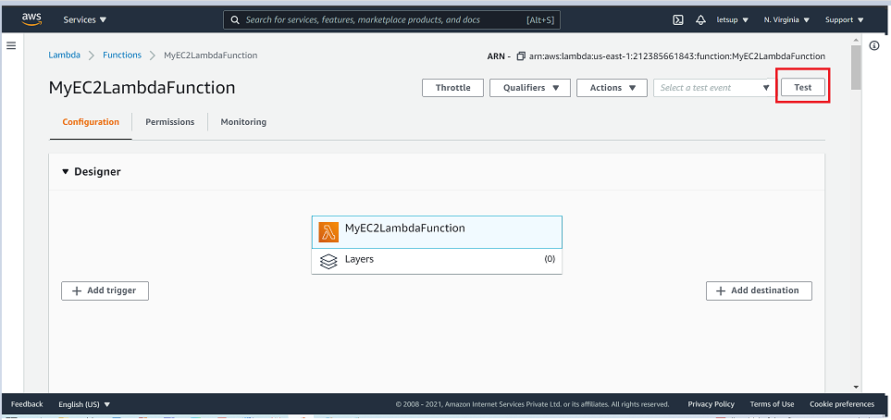

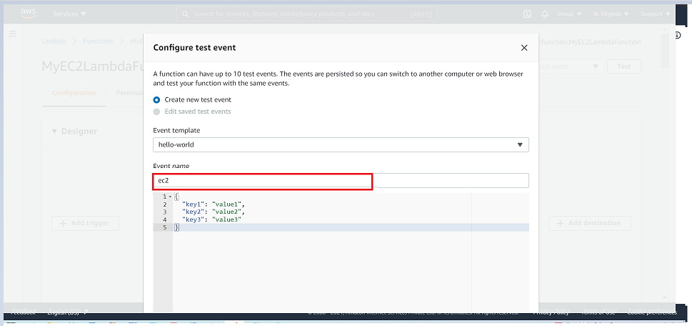

**TASK 5: Trigger the lambda functionality using the test events**

**SS6: Details of instance deployed from lambda console**

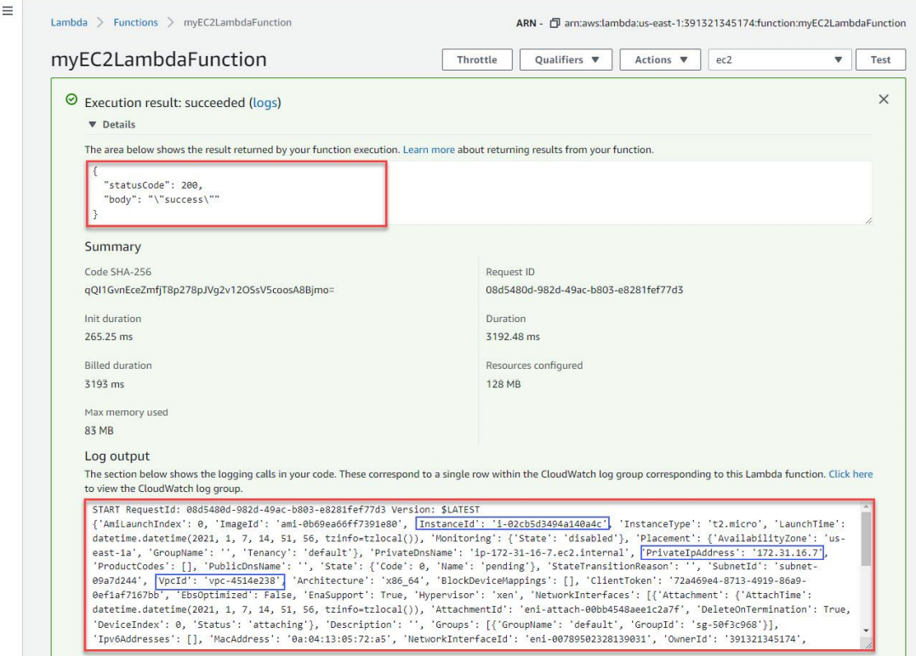

**SS7: EC2 Dashboard with instance details**

